Angular 21 DevTools
Source: https://angular.dev/tools/devtools
Angular DevTools is a browser extension that provides debugging and profiling capabilities for Angular applications.
- Install Angular DevTools from the Chrome Web Store or from Firefox Addons.
- You can open Chrome or Firefox DevTools on any web page by pressing F12 or Ctrl+Shift+I
(Windows or Linux) and Fn+F12 or Cmd+Option+I (Mac). Once browser DevTools is open and Angular DevTools is installed, you can find it under the "Angular" tab.

Note: Chrome's new tab page does not run installed extensions, so the Angular tab will not appear in DevTools. Visit any other page to see it.

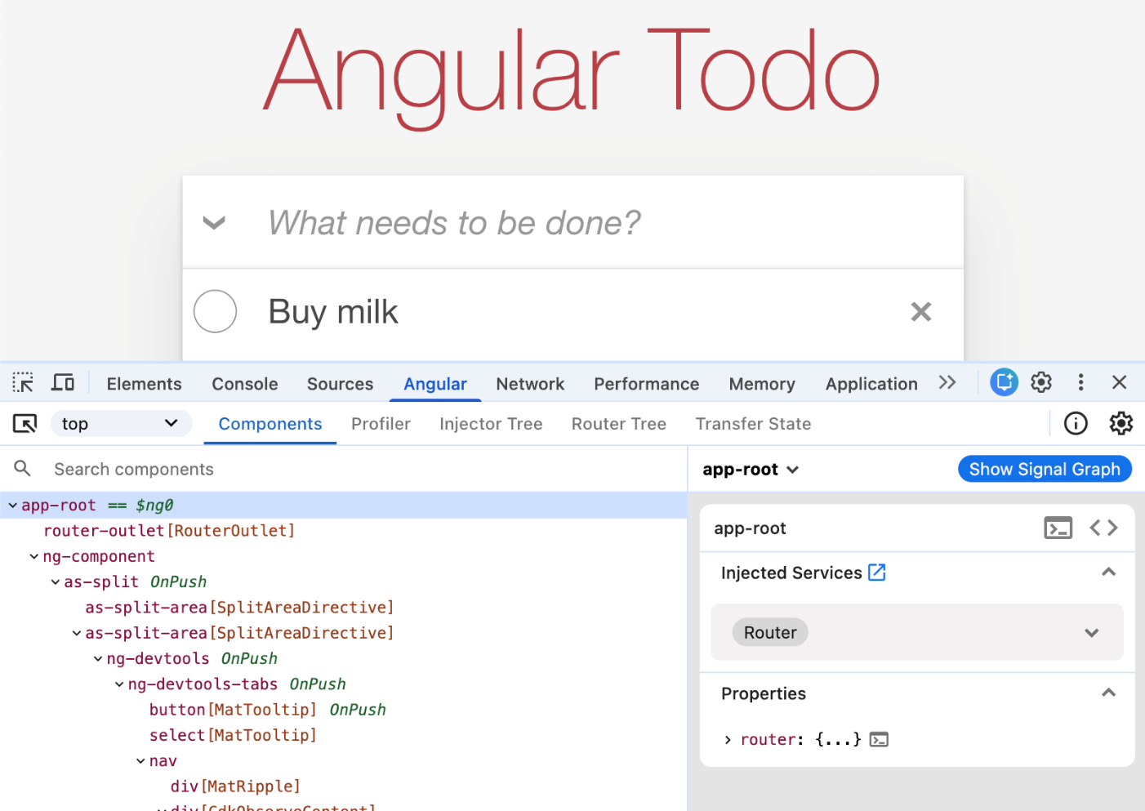

- Open your application. When you open the extension, you'll see four additional tabs:
Tabs | Details
Components | Lets you explore the components and directives in your application and preview or edit their state.
Profiler | Lets you profile your application and understand what the performance bottleneck is during change detection execution.
Injector Tree | Lets you visualize the Environment and Element Injector hierarchy
Router Tree | Lets you visualize the routing tree of your application.

Note: Other tabs like Transfer State are experimental and can be enabled via the devtools settings.

Note: For users of Chromium based browsers, you might be interested in the Performance panel integration.

- In the top-right corner of Angular DevTools you'll find the information button which open a popover. The information popover contains among others what version of Angular is running on the page as well as the devtools version.
